Swachha Bharat Pakhawra-2018
16 December – 31 December
ICAR-Central Inland Fisheries Research Institute, Barrackpore, Kolkata

Day 1: 16.12.2018
Display of banner at the institute
Different posters and banners were installed and displayed in the institute territory. The banners were designed so as to generate awareness on cleanliness and sanitation among the people of the locality and also the institute staff. Employees of the institute took active part in the activity.

Day 2: 17.12.18
Inauguration of Swachha Bharat Pakhawra -2018

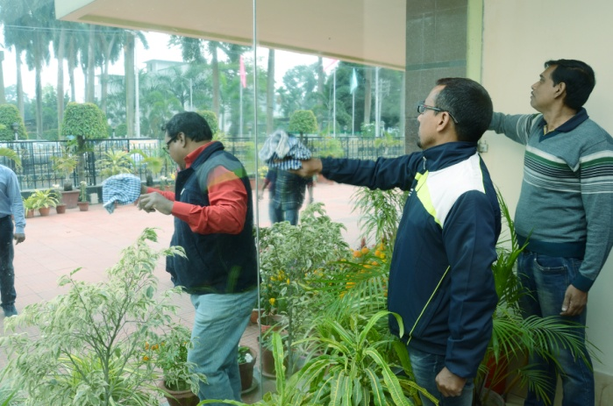
“Swachha Bharat Pakhawra 2018” was inaugurated on december 17, 2012 at 11 o’clock in the morning with pledge taking ceremony in which all staff of ICAR-CIFRI participated. The programme was followed by cleaning of the lobbies and corridors of the main building of the institute by the institute staff. The day witnessed another activity of weeding out of unserviceable items at the Stores Section of ICAR-CIFRI, Barrackpore. The unserviceable Store items were catalogued, identified and listed for condemnation and auction at the Stores Section by the concerned employees of the institute.
